Your own Instagram filter

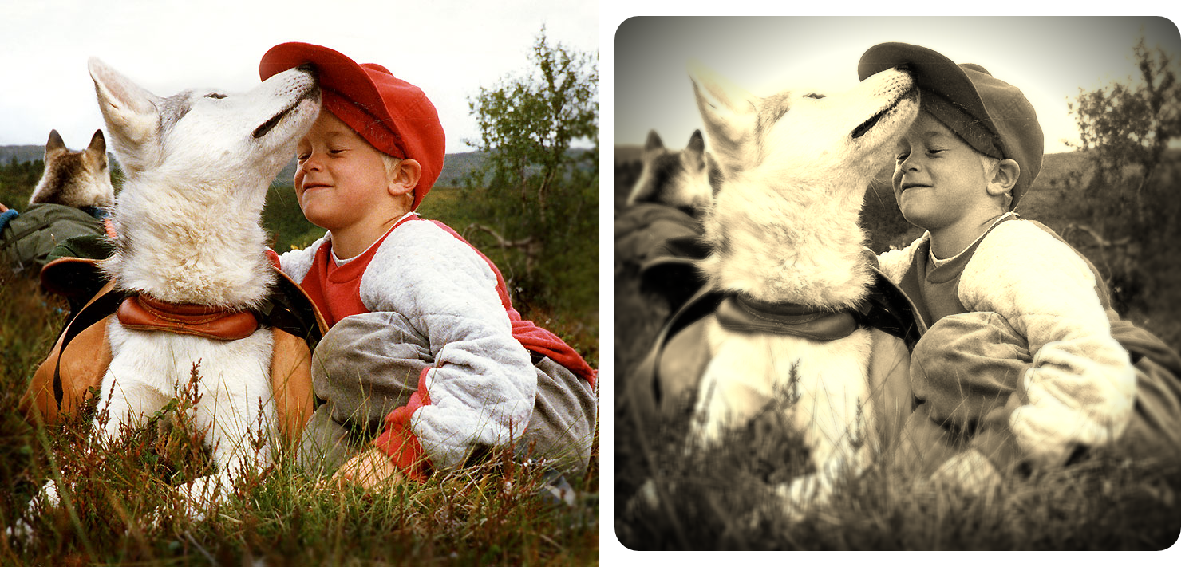

Instagram has a large collection of filters. In this assignment we’ll try to create our own, copying features from a few of them in order to achieve the effect you see in the image above.

Start by downloading the **instagramFilter-Template** folder.

* 1. The template code provides the general outline for how this filter will work. We’ll call this filter the early bird filter because it looks a bit like the one by Instagram. Notice how the filter itself is a function called earlyBirdFilter() which takes an image as an input and returns an image as output. When you run the code the first time you should see the original picture of the boy with the Husky on the left and the rest of the gray canvas on the right. As you’ll work through the code you’ll be uncommenting each line in the earlyBirdFilter() function and implementing the sub-filters that make it up. Filters in social media apps are often combinations of simpler filters we have already examined.
  2. **Important:** Please use the image we provided in order for us to be able to compare results and be able to mark you.
  3. Let’s get to it!

## Steps to complete

**Step 1:** Inside earlyBirdFilter() function, uncomment the line that calls the sepiaFilter(). Implement the sepiaFilter() function. The basis of this filter is one of the simple filters we saw in class (eg. invertFilter). Copy the code over and modify it to turn the image into sepia. A simple implementation involves the following conversion of each channel of all pixels.

newRed = (oldRed * .393) + (oldGreen *.769) + (oldBlue * .189)  
newGreen = (oldRed * .349) + (oldGreen *.686) + (oldBlue * .168)  
newBlue = (oldRed * .272) + (oldGreen *.534) + (oldBlue * .131)

Importantly, make sure to constrain *newRed, newGreen* and *newBlue* to values between 0 and 255. Remember to make sepiaFilter() return the resulting image. If you’ve done things right you should be seeing the image below.

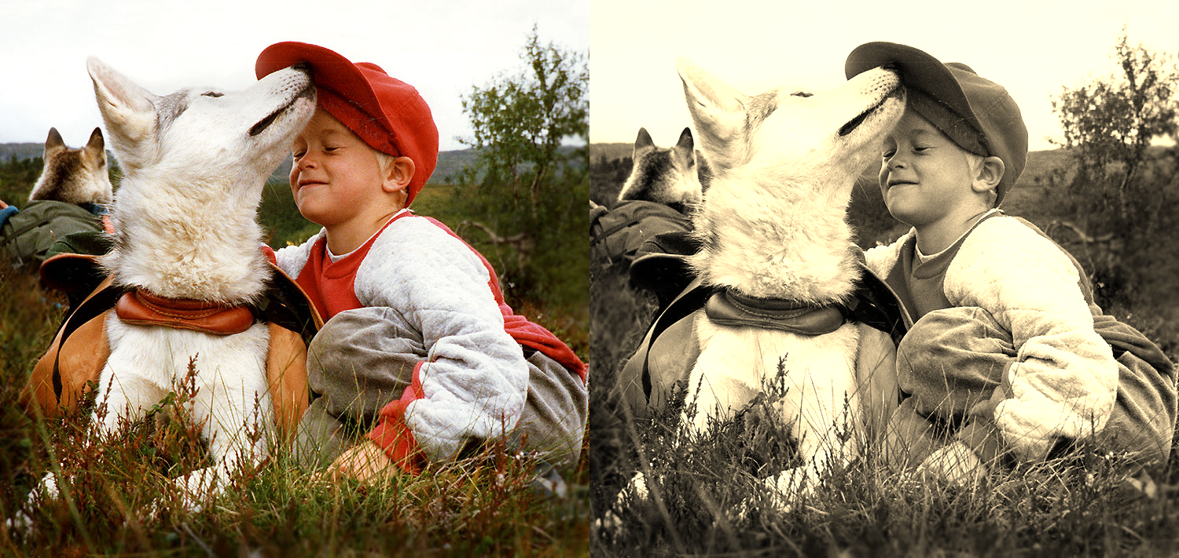

**Step 2:** Adding dark corners, also known as vignetting, will give our image a slightly older feel. Uncomment the next line in the earlyBirdFilter() that calls the darkCorners() function and implement the corresponding filter. The basis of this filter is a simple filter like above. What you’ll need to do is adjust the luminosity / brightness of the pixel by scaling each color channel. Pixels that are:  
* up to 300 pixels away from the center of the image – no adjustment (multiply each channel by 1)  
* from 300 to 450 scale by 1 to 0.4 depending on distance  
* 450 and above scale by a value between 0.4 and 0

Hint: You’ll need to use the map() and constrain() functions in order to remap the distance of each pixel to a new variable called *dynLum* (for dynamic luminance) which will hold the scaling that will be required for each channel. If you’ve done things right you should see an image like the one below.

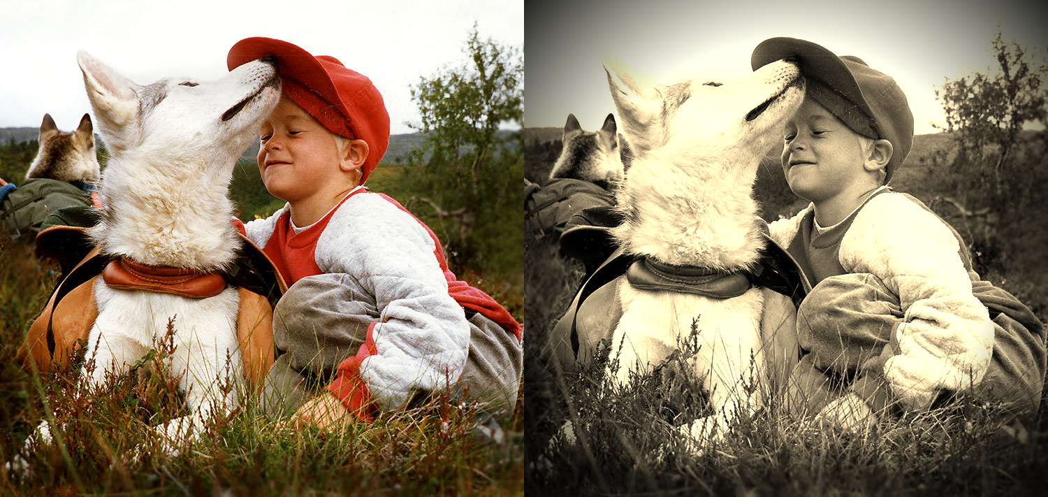

**Step 3:** Uncomment the next line in the earlyBirdFilter() that calls the radialBlurFilter() function and implement the corresponding filter. The basis of this filter is the blur filter we saw in class. However, this time we’ll create a radial filter that blurs more as you move away from it’s center. We’ll also use a bigger kernel as you have seen at the top of the template. Copy over the blur filter and the convolution function from the examples demonstrated in class. The main difference will be in how the new values are calculated. Just after the convolution call inside the blur function, we would need to update the each channel of the specific pixel as we’re doing below for the red channel:

imgOut.pixels[index + 0] = c[0]*dynBlur + r*(1-dynBlur);

where *c[0]* is the red channel returned from the convolution, *r* is the red channel in the original image and *dynBlur* is a value we generated using the distance from the mouse. For each pixel we need to calculate the distance between it and the mouse **on the color image**. We need to remap the distance from a range 100 to 300 to a new range from 0 to 1. We then need to constrain the returned value from 0 to 1 and save it in the *dynBlur* variable.

What the *dynBlur* variable allows us to do when used in the operation above is to say how much of the blur we want to use. When the pixels are up to 100 pixels from the mouse they are clear (the original image values are used and none of the ones returned from the convolution). As the distance from the mouse increases from 100 to 300, more of the blurred image is gradually used until 300 is reached after which only the blurred image is used and none of the original (aka clear) image.

Please note: because this operation is slow we have used the noLoop() command inside the draw() function therefore the mouseX and mouseY are not updated until you click somewhere. Click on the part of the color image you want to place at the center of the radialBlurFilter().

If you have done things right you should see something like the image below. I clicked on the face of the boy in the color image. Notice the radial blur centered around there.

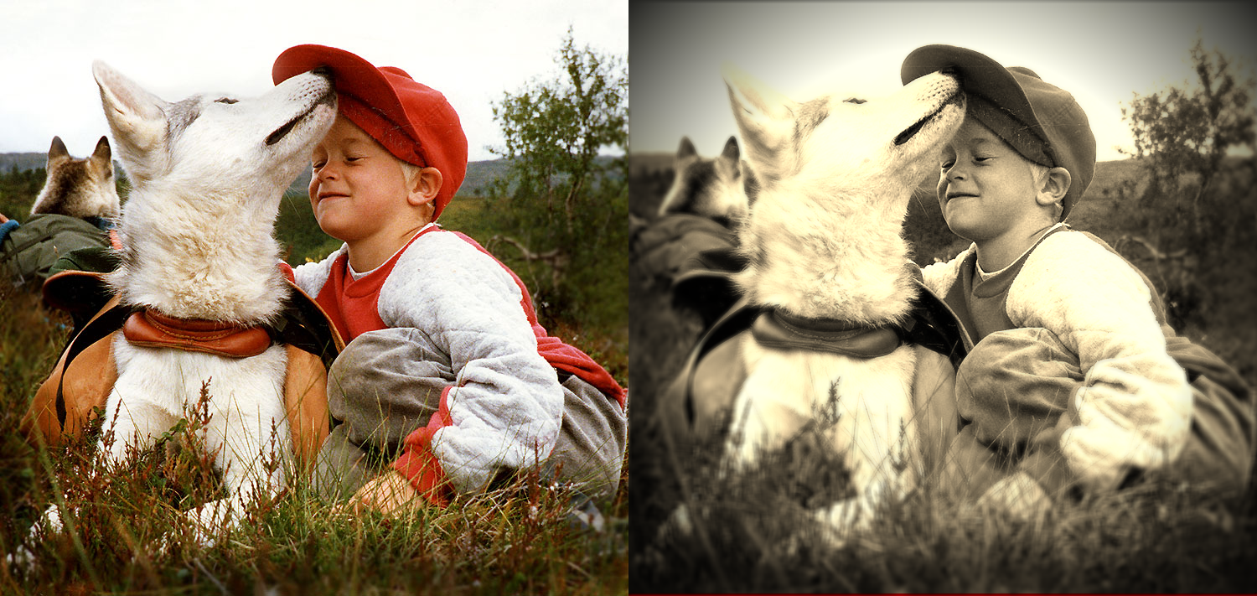

Step 4: The final touch: Let’s add a border around the image. To do this we’ll have to implement the borderFilter() function. Like all of the above filters this one will also take an image *img* as an input and then create a local buffer called *buffer* of the same size as the input image (Hint: you’ll do this using the createGraphics() command). Draw the *img* onto the *buffer*. And draw a big, fat, white rectangle with rounded corners around the image. See the documentation about drawing rectangles with round corners [here](https://p5js.org/reference/#/p5/rect). This should create an rectangle like the one seen below. Make sure you return the *buffer* at the end of the function.

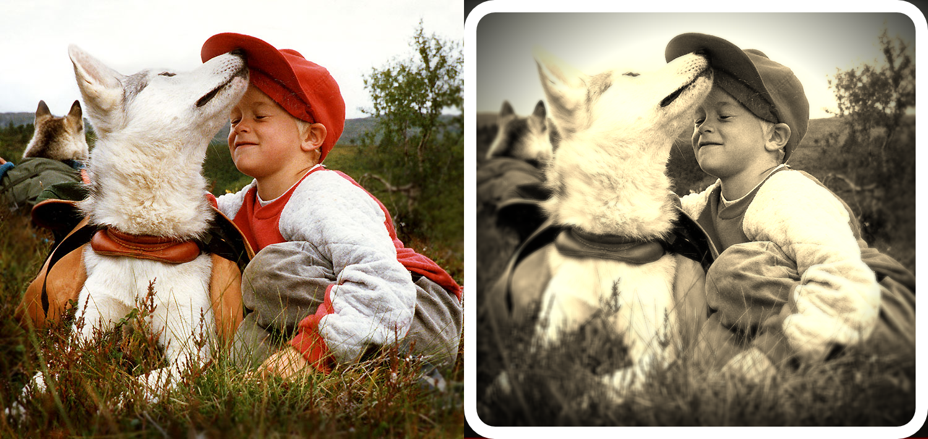Draw another rectangle now, without rounded corners in order to get rid of the little triangles so you end up with the image below.

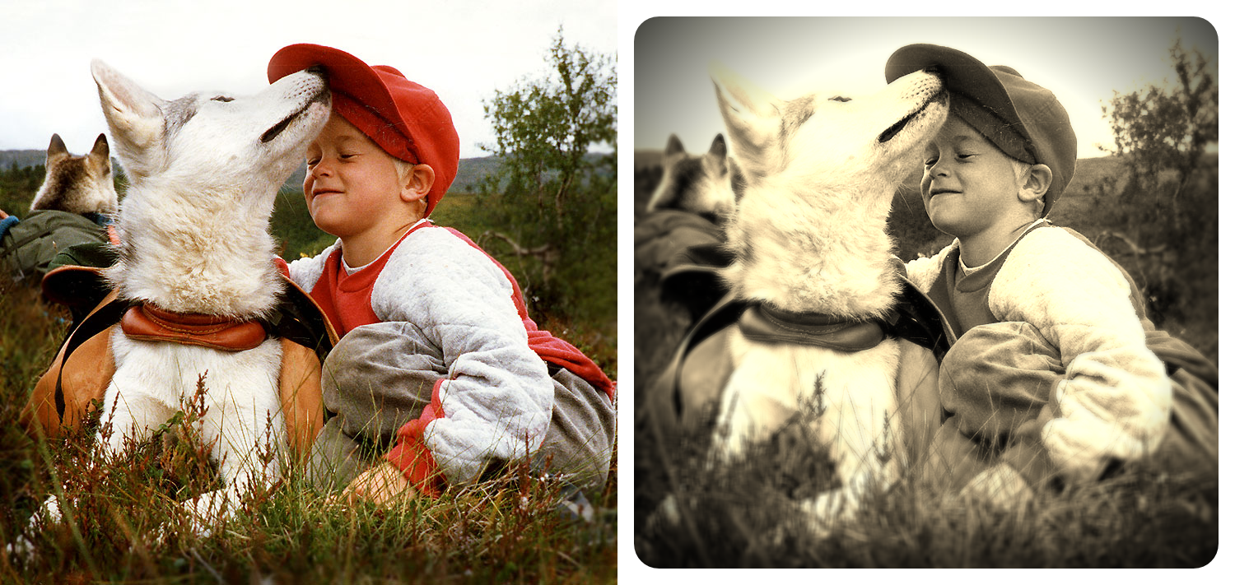

## Marking rubric

Step 1 – [2 points]: Sepia filter has been implemented successfully and images look very similar to the ones provided by the instructor.

Step 2 – [3 points]: Vignetting has been achieved using the map() and constrain() functions (code check required) and results look very similar to the ones provided by the instructor.

Step 3 – [3 points]: Radial blur has been achieved using the map() and constrain() functions (code check required). Clicking on the face of the boy in the color image replicates the results provided by the instructor.

Step 4 – [2 points]: Borders recreated using the technique suggested by the instructor.

Full marks: Step has been achieved.

Half marks: Reasonable attempt but doesn't quite work.

Zero marks: Not attempted.